22_STP – Spanning Tree Protocol (One Page)
What is STP?
STP (Spanning Tree Protocol) is a Layer-2 protocol used in switches to prevent loops in a network.
When you connect switches with multiple paths (redundant links), loops can occur.
STP automatically blocks some ports, so the network forms a loop-free logical topology.

Why STP is Needed
Without STP, switching loops cause:
- Broadcast storms
- MAC table instability
- Duplicate frames
- Entire network outage
STP avoids this by:
- Electing a Root Bridge
- Choosing the best path to the root
- Blocking unnecessary links
So, the network stays stable even with redundancy.

Advantages of STP
1. Prevents Layer-2 loops
Stops broadcast storms and keeps network from crashing.
2. Allows redundancy
You can connect switches with multiple links safely.
3. Automatic failover
If an active link goes down, STP unblocks the backup link.
4. Stabilizes the network
Ensures predictable forwarding paths.
5. Works without manual intervention
Automatically calculates best path, roles, and port states.

Disadvantages of STP
1. Convergence is slow (traditional STP)
Takes 30–50 seconds to reconverge when a link fails.
2. Can block links unnecessarily
Some bandwidth stays unused because STP blocks redundant ports.
3. Misconfiguration can cause issues
Wrong root bridge = bad traffic flow, bottlenecks.
4. Hard to troubleshoot in large networks
Root elections, port states, and inconsistent configs can cause problems.
5. Relying only on STP is outdated
Modern networks prefer:
- RSTP (faster)
- MST (multi-instance)
- LACP/EtherChannel (loop-free bundles)

Valid STP Priority | Explanation
0 | Highest priority
4096 | Next priority
8192 | Next
12288 | ...
16384 | ...
20480 | ...
24576 | ...
28672 | ...
32768 (default) | Factory default
36864
40960
45056
49152 | Lowest

Configuration:
Core switch: enable
configure terminal
hostname INBOM25CS1

ip domain-name adityalab.com
username admin privilege 15 secret qwertyuiop

! Enable SSH v2
ip ssh version 2

! RSA key
crypto key generate rsa general-keys modulus 1024

ip routing

!-- VLANs
vlan 10
name Sales
exit

vlan 20
name HR
exit

vlan 30
name IT
exit

vlan 39
name Management
exit

!-- SVI interfaces
interface vlan 10
ip address 192.168.10.1 255.255.255.0
no shutdown
exit

interface vlan 20
ip address 192.168.20.1 255.255.255.0
no shutdown
exit

interface vlan 30
ip address 192.168.30.1 255.255.255.0
no shutdown
exit

interface vlan 39
ip address 192.168.1.10 255.255.255.0
no shutdown
exit

! Access ports
interface range gi1/0/1 - 6
switchport mode access
switchport access vlan 10
no shutdown
exit

interface range gi1/0/7 - 12
switchport mode access
switchport access vlan 20
no shutdown
exit

interface range gi1/0/13 - 18
switchport mode access
switchport access vlan 30
no shutdown
exit

! Management PC port
interface gi1/0/24
switchport mode access
switchport access vlan 39
no shutdown
exit

! ---- TRUNK PORT TO SWITCH 2 ----
interface gi1/1/4
switchport mode trunk
switchport trunk allowed vlan all
exit

! ---- DHCP POOLS ----
ip dhcp pool SALES
network 192.168.10.0 255.255.255.0
default-router 192.168.10.1
dns-server 8.8.8.8
exit

ip dhcp pool HR
network 192.168.20.0 255.255.255.0
default-router 192.168.20.1
dns-server 8.8.8.8
exit

ip dhcp pool IT
network 192.168.30.0 255.255.255.0
default-router 192.168.30.1
dns-server 8.8.8.8
exit

! Excluded addresses
ip dhcp excluded-address 192.168.10.1
ip dhcp excluded-address 192.168.20.1
ip dhcp excluded-address 192.168.30.1

! Enable SSH on VTY
line vty 0 4
login local
transport input ssh

! for history
history size 256

line console 0
history size 256

line vty 0 4
history size 256
exit

! Make CS root for all VLANs
spanning-tree vlan 10,20,30,39 priority 4096
exit

=========================================
DS1
spanning-tree vlan 10,20,30,39 priority 8192
============================================
DS2

spanning-tree vlan 10,20,30,39 priority 12288

===========================================
AS
spanning-tree vlan 10,20,30,39 priority 32768
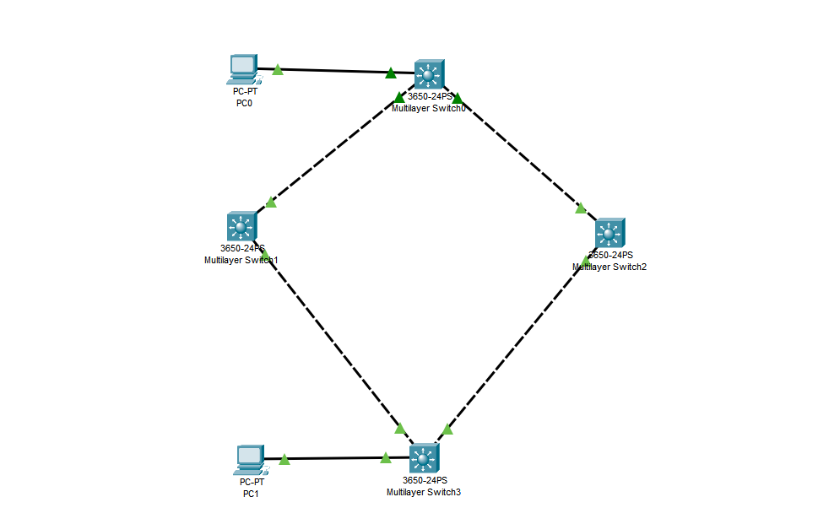

show spanning-tree vlan 10
show spanning-tree vlan 20
show spanning-tree vlan 30
show spanning-tree vlan 39
show spanning-tree summary

